Project Design Phase-I
Solution Architecture

Date | 1 November 2026
Team ID
Project Name | EV Market Performance & Insights Platform
Maximum Marks | 4 Marks

Solution Architecture:
Solution architecture is a complex process – with many sub-processes – that bridges the gap between business problems and technology solutions. Its goals are to:
- Find the best tech solution to solve existing business problems.
- Describe the structure, characteristics, behavior, and other aspects of the software to project stakeholders.
- Define features, development phases, and solution requirements.
- Provide specifications according to which the solution is defined, managed, and delivered.

Sample Solution Architecture Diagram:
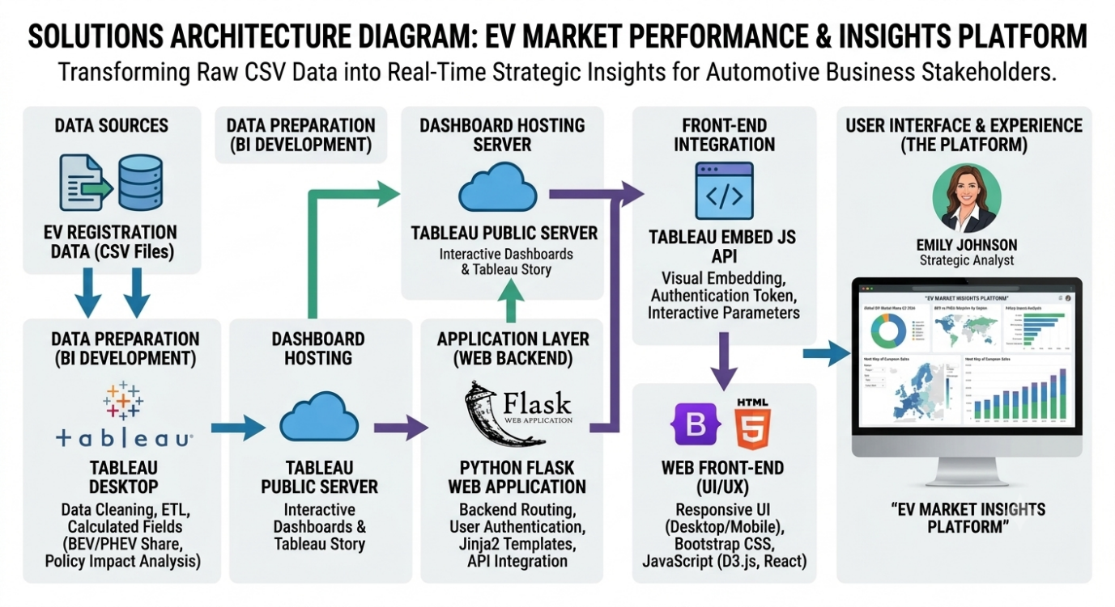

Component Description
Web Framework / Backend | Acts as the core server. It handles HTTP requests, routes users to the correct pages, and serves the application context. | Python, Flask (app.py)
Template Engine | Dynamically generates the HTML page by combining the static layout with any dynamic variables passed from the backend. | Jinja2 (templates/index.html)
Frontend / UI Layer | Provides the visual structure, responsive layout, and styling of the web application across all devices. | HTML5, CSS3, Bootstrap 5
Integration Layer | The JavaScript that runs in the browser to inject and render the interactive Tableau charts into the HTML page. | Tableau Embed API (viz_v1.js)
Data Visualization / BI | The analytics engine used to create the interactive dashboards, KPI metrics, and the guided Story narrative. | Tableau Desktop / Tableau Public
Data Source | The raw dataset containing global EV registrations, which is cleaned and connected to Tableau for visualization. | CSV Dataset

